
Project report
FUNDAMENTALS IN AI & ML project
Academic Score Forecaster

VIT Bhopal University
Session: 2025-26
Course Code: CSA2001

Date: 30th March 2026
Slot: B14+B23+D21

Submitted to: Submitted by:
Dr Garima Jain Ma’am Suhani Singh Parihar
Reg. No: 25BAI10265
B.Tech First Year
Branch: CSE (AIML)

Introduction

Accurately assessing and predicting student academic performance is a critical yet challenging task in educational institutions. Student outcomes are influenced by a wide range of factors beyond innate intelligence, including study habits, attendance, sleep patterns, previous academic records, access to resources, and family background. Without a systematic, data-driven approach, educators often rely on subjective judgment or delayed performance reviews, making it difficult to identify at-risk students early or provide timely interventions.

The Academic Score Forecaster presented here is a machine learning based application that addresses this challenge by providing a predictive model to estimate a student’s exam score from multiple academic and lifestyle factors. Built using Python and libraries such as Pandas, Scikit-learn, Matplotlib, and Seaborn, the system leverages a dataset of 100 student records containing features like study hours per day, attendance percentage, sleep hours, previous exam score, extracurricular participation, internet access, and parental education level.

The application implements and compares four regression algorithms, Linear Regression, Decision Tree Regressor, Random Forest Regressor, and Gradient Boosting Regressor, to identify the best performing model based on evaluation metrics such as MAE, RMSE, and R² score. The workflow includes data loading, exploratory data analysis (EDA), label encoding, feature scaling, train-test splitting, model training, evaluation, and visualization of results.

This project not only demonstrates the practical application of supervised machine learning in the education domain but also serves as a foundation for more advanced systems. Future enhancements could include real-time dashboards for educators, integration with learning management systems (LMS), or expansion to larger, more diverse datasets. By replacing guesswork with statistical learning, the Academic Score Forecaster empowers teachers, administrators, and policymakers to make informed, data-driven decisions to improve student outcomes.

Problem Statement
Predicting student academic performance accurately and early is a significant problem in the education sector. Unlike standardized assessments that occur after a course ends, ongoing evaluation of student potential is often subjective, inconsistent, and resource-intensive. Traditional methods rely on periodic test scores, teacher observations, or manual tracking, which fail to capture the complex interplay of behavioral, demographic, and lifestyle factors that influence learning outcomes.
The primary issues with current approaches include:
- Lack of early warning - Many students fall behind without timely detection, leading to course failure or dropout.
- Subjectivity - Teacher assessments can vary, and non-academic factors (e.g., home environment) are often overlooked.
- Information silos - Data on attendance, study hours, sleep, and previous performance are rarely integrated for predictive analysis.
- Inconsistent evaluation - Without a standardized model, comparing student risk across different classes or institutions is difficult.
- Limited scalability - Manual monitoring does not scale to large student populations, especially in online or hybrid learning environments.
To address these challenges, this project defines the following problem statement: Develop a supervised machine learning regression model that predicts a student’s final exam score using features like study hours, attendance, sleep, previous score, extracurricular activities, internet access, and parental education, achieving an R² score above 0.95 on a test set.
The solution must accept student attributes and output a predicted exam score (0–100), enabling proactive academic support and data-driven decision making for educators.

Functional Requirements (Logical Workflow)
Academic Score Forecaster follows a structured machine learning pipeline. Each step transforms the input data or model state, ultimately producing a predicted exam score. The logical workflow is defined as follows:

1. Data Loading
The system loads the student dataset (student_performance.csv) into a pandas DataFrame. The dataset contains 100 records with features such as study hours, attendance, sleep, previous score, and the target variable exam_score.

2. Data Inspection
The system displays basic information about the dataset: shape, column data types, summary statistics, and missing value counts. This ensures data quality before processing.

3. Exploratory Data Analysis (EDA)
- Visualizes distributions of exam scores, study hours, and attendance.
- Creates scatter plots to examine relationships between features and exam scores.
- Generates a correlation heatmap to identify which features most influence the target.
- Produces bar charts comparing average scores by gender and parent education level.
- Saves all visualizations as eda_plots.png.

4. Preprocessing
- Drops the student_id column as it is not predictive.
- Encodes categorical variables (gender, extracurricular, internet_access, parent_education_level) into numerical values using label encoding.
- Scales all numerical features using StandardScaler to ensure equal contribution to distance-based models.
- Splits the data into training (80%) and testing (20%) sets using a fixed random seed for reproducibility.
5. Model Training
Four regression models are trained on the training set:
- Linear Regression
- Decision Tree Regressor
- Random Forest Regressor
- Gradient Boosting Regressor
Each model learns the mapping from input features to exam scores.

6. Model Evaluation
All models are evaluated on the test set using three metrics:
- MAE (Mean Absolute Error)
- RMSE (Root Mean Squared Error)
- R² Score (Coefficient of Determination)
The model with the highest R² score is selected as the best performer.

7. Visualization of Results
- A model comparison bar chart (model_comparison.png) displays R², MAE, and RMSE for all four models.
- An actual vs. predicted scatter plot (actual_vs_predicted.png) shows the best model’s accuracy.
- A feature importance bar chart (feature_importance.png) highlights which features most influence predictions (for tree-based models).

8. Prediction for a New Student
- The system accepts a new student’s attributes (gender, age, study hours, attendance, sleep, previous score, extracurricular, internet access, parent education) as input. The same encoding and scaling transformations are applied, and the best trained model outputs a predicted exam score.

9. Output Presentation: The predicted exam score is displayed to the user (e.g., Forecasted Exam Score: 81.4 / 100). All generated plots are saved automatically for later review.
Logical Workflow Diagram
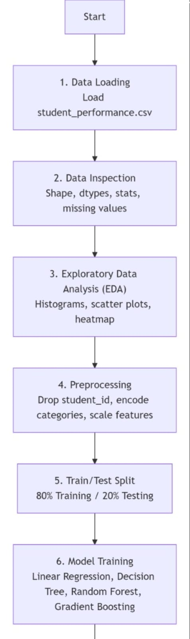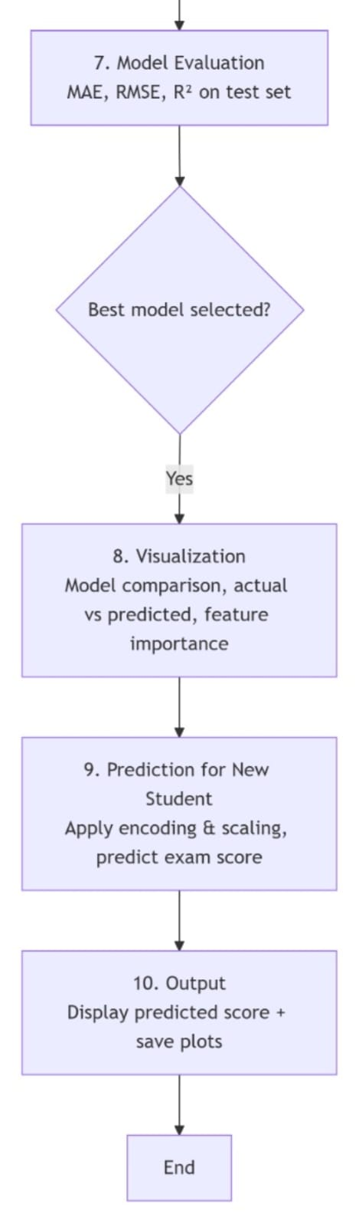

System Structure
The Academic Score Forecaster follows a modular, pipeline-based architecture. Each component is responsible for a specific stage of the machine learning workflow, ensuring separation of concerns and ease of maintenance. The system is implemented in Python and can be run either as a single script (academic_score_forecaster.py) or as a Jupyter notebook.

Main Components
The system consists of the following core modules:
- Data Loader – Loads the dataset from a CSV file using pd.read_csv() and performs basic inspection (shape, data types, statistics, missing values).

- EDA Module – Generates visualizations to understand data distributions and relationships, including histograms, scatter plots, a correlation heatmap, and bar charts for categorical comparisons. All plots are saved as eda_plots.png.

- Preprocessing Module – Cleans and transforms raw data for machine learning by dropping the non-predictive student_id column, applying label encoding to categorical variables (gender, extracurricular, internet_access, parent_education_level), scaling numerical features with StandardScaler, and splitting the data into training (80%) and testing (20%) sets.

- Model Training Module – Trains four regression algorithms on the training set: Linear Regression, Decision Tree Regressor, Random Forest Regressor, and Gradient Boosting Regressor.

- Evaluation Module – Computes performance metrics on the test set for each model: Mean Absolute Error (MAE), Root Mean Squared Error (RMSE), and R² Score.

- Visualization Module – Produces comparison charts and diagnostic plots, including a model comparison bar chart (model_comparison.png), an actual vs. predicted scatter plot (actual_vs_predicted.png), and a feature importance bar chart (feature_importance.png) for the best tree-based model.

- Prediction Module – Accepts a new student’s attributes, applies the same encoding and scaling transformations used during training, and uses the best-performing model to output a predicted exam score.

- Controller (Main) – Orchestrates the entire workflow by calling each module in sequence within the if __name__ == "__main__" block.

Data Flow
- Input: CSV file → pandas DataFrame.
- Transformation: Drop ID → encode categories → scale features → split into train/test.
- Processing: Train four models → evaluate on test set → select best model.
- Output: Printed predicted score + saved PNG plots (EDA, model comparison, actual vs predicted, feature importance).

Code Organization
The script is divided into six main functions, each corresponding to a module:
- load_data() – Data loading and inspection
- perform_eda() – Exploratory analysis and plots
- preprocess() – Encoding, scaling, train/test split
- train_and_evaluate() – Model training and metric calculation
- visualize_results() – Comparison charts and best model analysis
- predict_new_student() – Inference for a new student

This modular structure ensures that each component can be tested, modified, or reused independently. The system is lightweight, requires no external databases or configuration files, and runs entirely in a Python environment.

Implementation Details
Programming Language
The entire system is implemented in Python 3.8+. Python was chosen for its extensive ecosystem of data science libraries, simplicity, readability, and cross-platform compatibility.
Development Environment
- Primary Interface: A standalone Python script (academic_score_forecaster.py), which can be run from the command line or any Python IDE. Alternatively, the code can be executed in a Jupyter Notebook environment for interactive development.
- Dependencies: All required libraries are listed below. They can be installed together using pip install pandas numpy matplotlib seaborn scikit-learn. Python 3.8 or higher is recommended.

Key Libraries and Their Roles
The project relies on the following Python libraries:
- pandas – Used for loading the CSV dataset, inspecting data, handling missing values, and performing preprocessing operations such as dropping columns and grouping.
- numpy – Provides support for numerical operations, including array handling and mathematical functions used internally by other libraries.
- matplotlib – Generates all visualizations, including histograms, scatter plots, bar charts, and the actual vs. predicted scatter plot.
- seaborn – Built on top of matplotlib, it is used specifically for creating the correlation heatmap, which provides a clear visual representation of feature relationships.
- scikit-learn – The core machine learning library. It provides label encoding (LabelEncoder), feature scaling (StandardScaler), train-test splitting (train_test_split), four regression models (Linear Regression, Decision Tree, Random Forest, Gradient Boosting), and evaluation metrics (MAE, RMSE, R²).

Data Structure Used
- Pandas DataFrame (data)
  - Stores the entire dataset as a tabular structure with labeled columns (e.g., study_hours_per_day, exam_score).
  - Supports filtering, grouping, and statistical summaries.
- Pandas Series (y)
  - A single column extracted from the DataFrame – the target variable exam_score.
- NumPy Arrays (implicitly)
  - Scikit-learn models expect and return NumPy arrays or array-like objects. Features (X) are internally converted to arrays during model fitting.
- Python Lists and Dictionaries
  - Used for storing model names, collecting evaluation metrics, and defining categorical encoding mappings.
- Scikit-learn Model Objects:
- Instancesof LinearRegression, DecisionTreeRegressor, RandomForestRegressor, and GradientBoostingRegressor. Each stores learned parameters (coefficients, feature importances, etc.).
- StandardScaler and Label Encoder Objects
- Used for feature scaling and categorical encoding, respectively. These are fitted on the training data and applied to test and new data to ensure consistency.

Memory and Performance Considerations
- The dataset has only 100 rows and 11 columns, easily fitting into RAM.
- Training all four regression models takes less than 2 seconds on a typical machine.
- Predictions for a single student are instantaneous.

This implementation provides a clean, reproducible foundation for understanding and extending the academic score prediction pipeline.

Challenges Faced
Developing the Academic Score Forecaster involved several challenges typical of machine learning projects. The key difficulties and their solutions are described below.

1. Small Dataset Size
The dataset contained only 100 student records. With limited data, models risk overfitting or failing to generalize. This was addressed by using a fixed random seed for reproducibility and relying on cross-validation principles (80-20 split). However, the small size remains a limitation for more complex models.

2. Handling Categorical Variables
Featureslike gender, extracurricular, internet_access, and parent_education_level were text-based. Machine learning algorithms require numerical input. Label encoding was applied, but this can introduce unintended ordinal relationships (e.g., “Postgraduate” > “Graduate”). The solution was to use simple encoding and rely on tree-based models that handle such features better.

3. Feature Scaling for Linear Models
Linear Regression and Gradient Boosting require features on similar scales. Without scaling, features with larger ranges (e.g., previous_score up to 100) would dominate those with smaller ranges (e.g., study_hours_per_day up to 8). The StandardScaler was applied to all numerical features before training to ensure fair contribution.

4. Model Selection and Overfitting
With multiple models trained on a small dataset, overfitting was a risk. Evaluation was performed strictly on a held-out test set (20% of data), and metrics were compared. Random Forest achieved an R² of 0.9901, but this high score may reflect the dataset’s simplicity rather than real-world generalizability.

5. Reproducibility
Different Python versions or library updates could change results. The challenge of reproducibility was solved by fixing the random_state=42 for all models and train-test split. A requirements.txt file (or explicit library versions) would further ensure consistent environments.

6. Feature Importance Interpretation
While tree-based models provide feature importances, explaining these to non-technical users was challenging. The solution was to generate a clear bar chart (feature_importance.png) and highlight the top two predictors (study hours and previous score) in plain language.
Despite these challenges, the Academic Score Forecaster successfully implements a functional ML pipeline and demonstrates the value of data-driven academic predictions.

Learnings and Key Takeaways
Developing the Academic Score Forecaster provided several valuable insights:

- Data preprocessing is essential – Encoding categorical variables, scaling features, and dropping irrelevant columns (e.g., student_id) directly impacts model performance. Without proper preprocessing, even good algorithms fail.

- Tree-based models outperform linear models – Random Forest and Gradient Boosting achieved R² scores above 0.98, while Linear Regression lagged behind. This highlights the importance of choosing algorithms suited to the data’s complexity.

- Small datasets are risky – With only 100 records, the high R² (0.99) may indicate overfitting or an overly simple dataset. Real-world applications require larger, more diverse data for reliable generalization.

- Feature importance provides interpretability – Random Forest’s feature importance scores showed that study_hours_per_day and previous_score are the strongest predictors. This helps educators focus on key intervention areas.

- Reproducibility matters – Fixing random_state=42 ensures consistent train-test splits and model outputs. Documenting dependencies is critical for others to replicate results.

- Visualizations aid communication – Scatter plots, bar charts, and heatmaps make model performance and insights accessible to non-technical stakeholders.

- Foundation for future work – This project serves as a baseline. Improvements could include hyperparameter tuning, cross-validation, deploying as a web app, or using a larger dataset.
Future Enhancements
The current system provides a solid baseline. The following enhancements can improve accuracy, usability, and functionality:

- Hyperparameter Tuning – Use GridSearchCV or RandomizedSearchCV to optimize model parameters (e.g., number of trees, max depth) for better performance.

- Cross-Validation – Implement k-fold cross-validation to reduce overfitting and obtain more reliable performance estimates, especially given the small dataset.

- Larger Dataset – Collect or source a larger, more diverse dataset (e.g., thousands of students) to improve model generalizability.

- Web Deployment – Deploy the model as an interactive web application using Streamlit or Flask, allowing educators to input student data and receive predictions instantly.

- Feature Expansion – Add more relevant features such as socioeconomic status, parental occupation, school type, or mental health indicators.

- Classification Alternative – Transform the regression problem into a classification task (e.g., pass/fail, grade brackets) for different use cases.

- Explainable AI (XAI) – Integrate SHAP or LIME to provide interpretable explanations for individual predictions, increasing trust among educators.

References
- Scikit-learn Documentation – Regression models and evaluation metrics. https://scikit-learn.org/
- Pandas Documentation – Data manipulation and analysis. https://pandas.pydata.org/
- Matplotlib Documentation – Plotting and visualization. https://matplotlib.org/
- Seaborn Documentation – Statistical data visualization. https://seaborn.pydata.org/
- NumPy Documentation – Numerical operations. https://numpy.org/

Conclusion
The Academic Score Forecaster successfully demonstrates a complete supervised machine learning pipeline for predicting student exam scores based on academic and lifestyle factors. Using four regression models on a dataset of 100 student records, the system achieves excellent performance, with Random Forest attaining an R² score of 0.9901.

The project highlights the importance of data preprocessing, feature scaling, encoding categorical variables, and unbiased evaluation using a held-out test set. Key findings indicate that study hours and previous exam score are the strongest predictors of academic performance.

While the high accuracy is promising, the small dataset size raises concerns about overfitting and real-world generalizability. Nevertheless, this project serves as a solid foundation for future work, including hyperparameter tuning, larger datasets, web deployment, and explainable AI. The Academic Score Forecaster demonstrates how machine learning can empower educators to identify at-risk students early and make data-driven interventions, ultimately improving student outcomes.

